**PROJECT**

**Preparation and Maintenance of Zoho Books of Accounts for :**

**Bright Ideas Consulting (Professional Services – Industry)**

**Milestone-1**

**Service Creation that Bright Ideas Consulting Offering :**

1. Management Consulting :

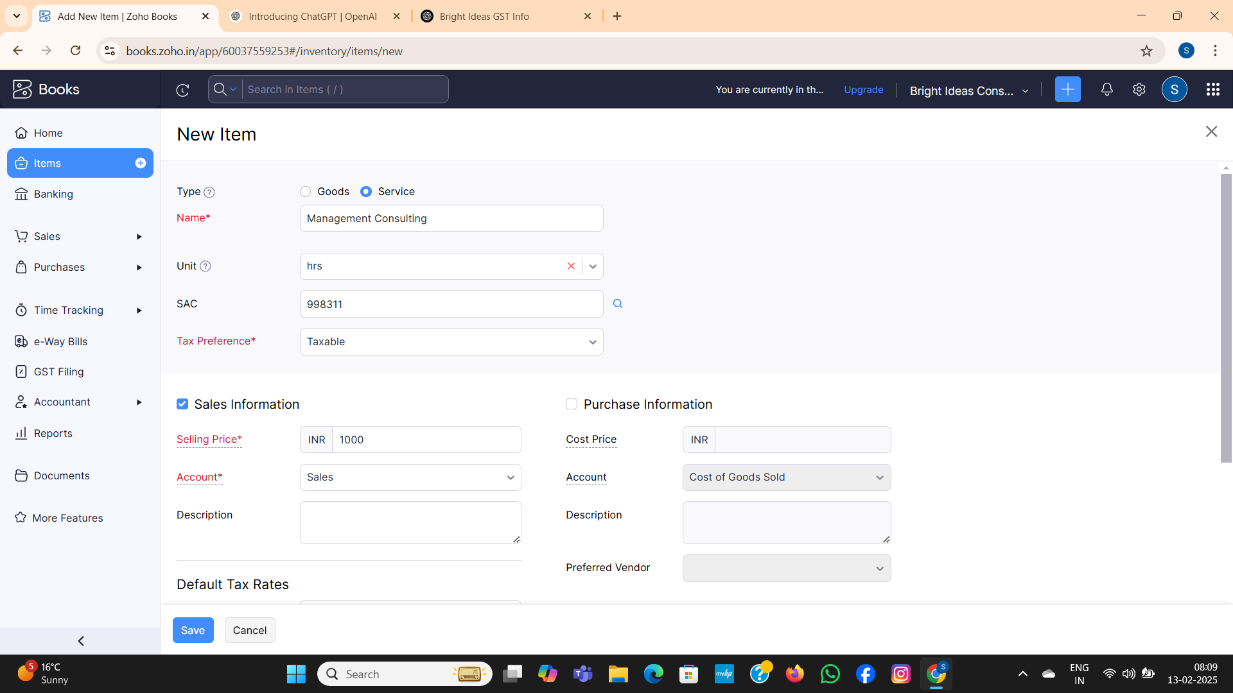

1. Financial Consulting :

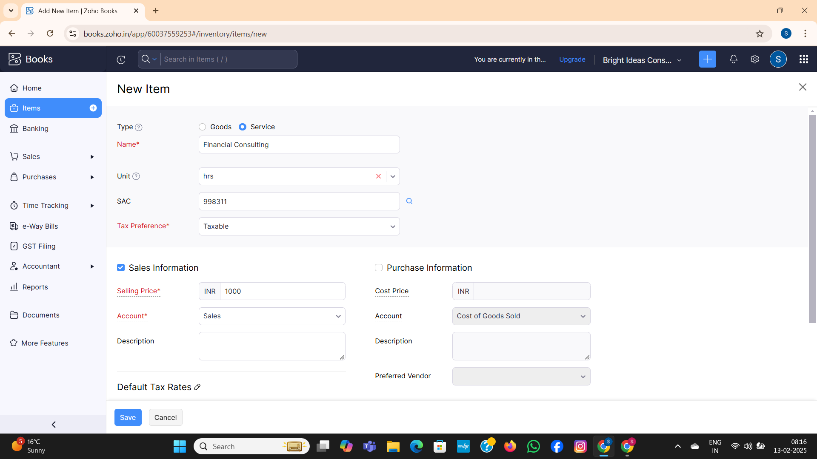

1. Human Resources (HR) Consulting

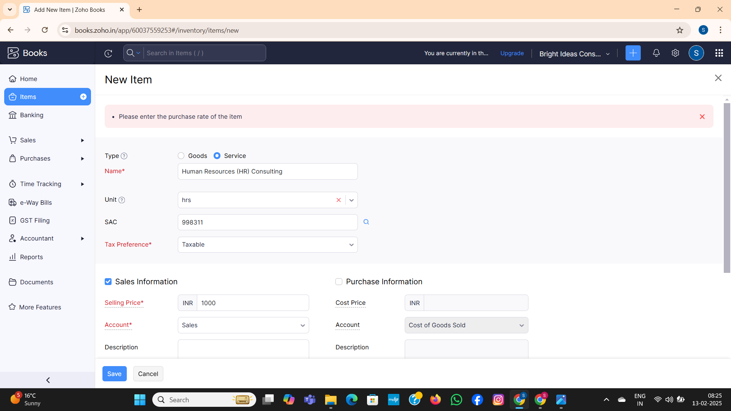

1. Legal Consulting:

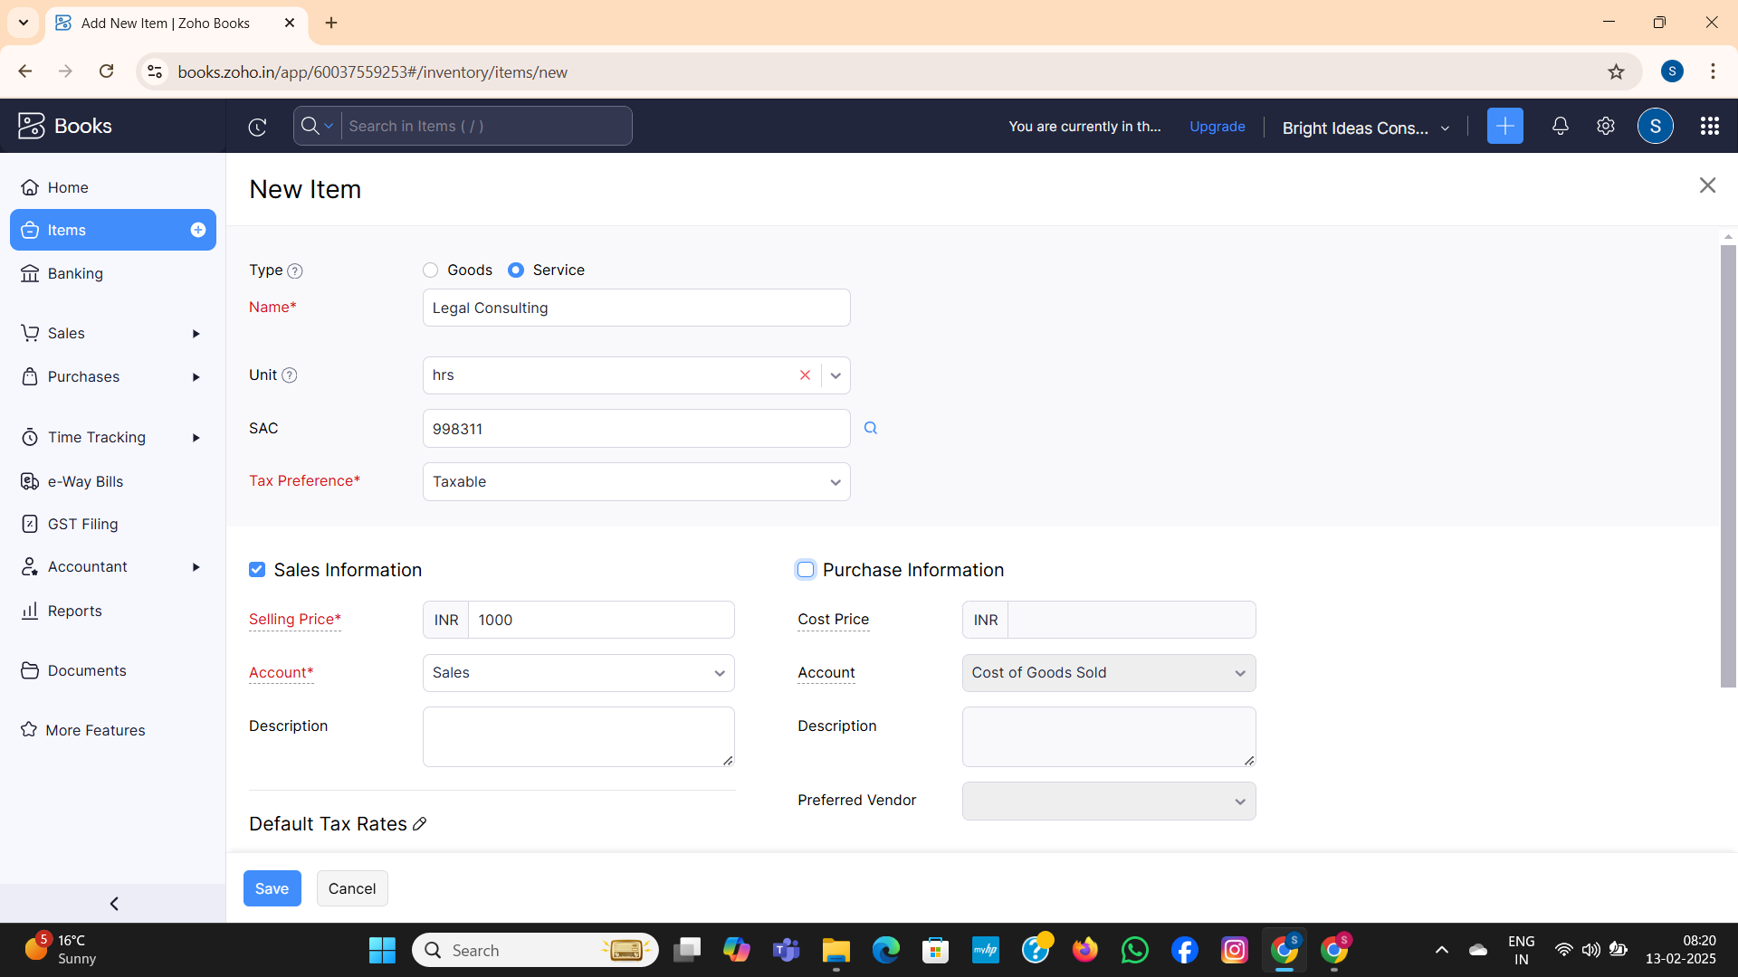

Note- Selling Price for all the above services is Rs.1000/- per consulting hours. Output GST @ 18% is applicable for all the above services.

**Milestone-2**

**Creation of Vendors-**

1. **Randstad Technologies ( GST Registered )**

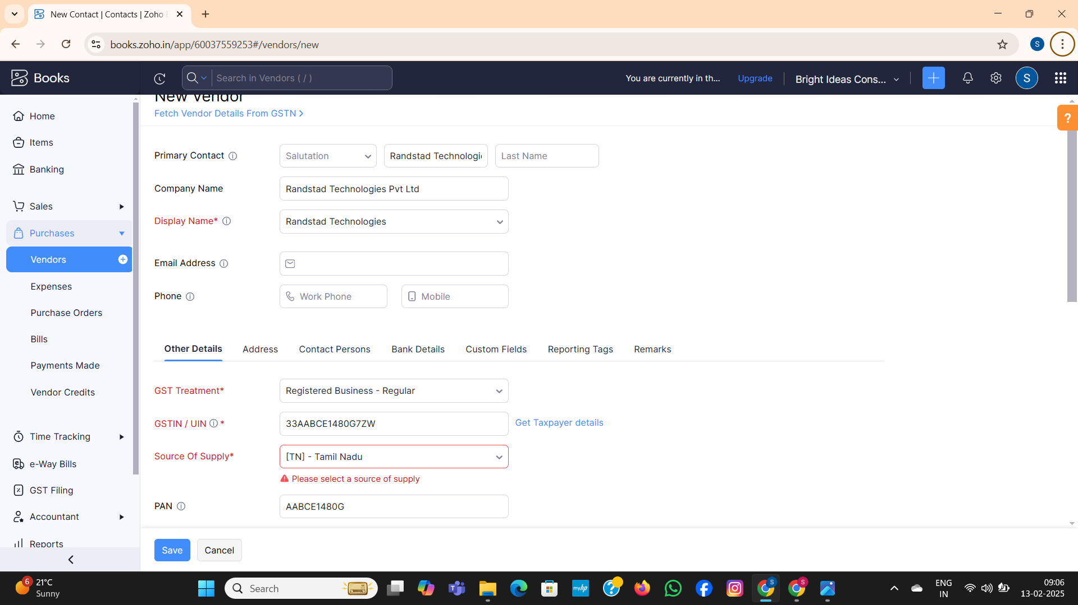

1. **Amazon Web Services ( GST Registered )**

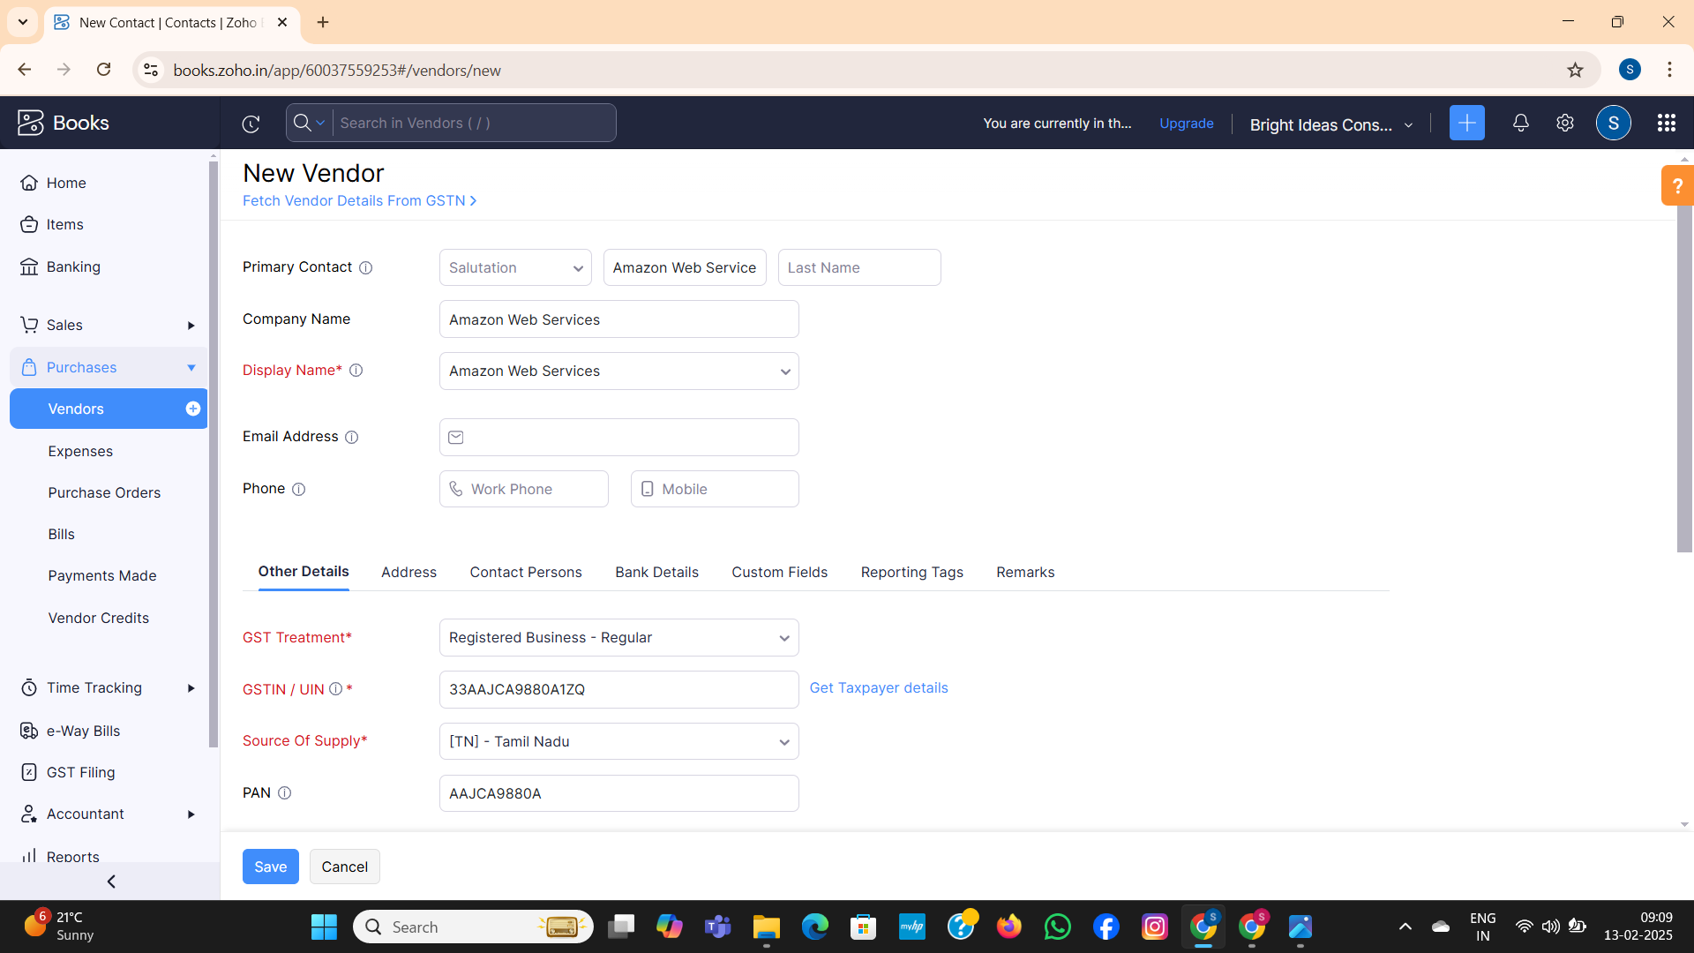

1. **Raj Kamal External Consulting ( Non GST Registered )**

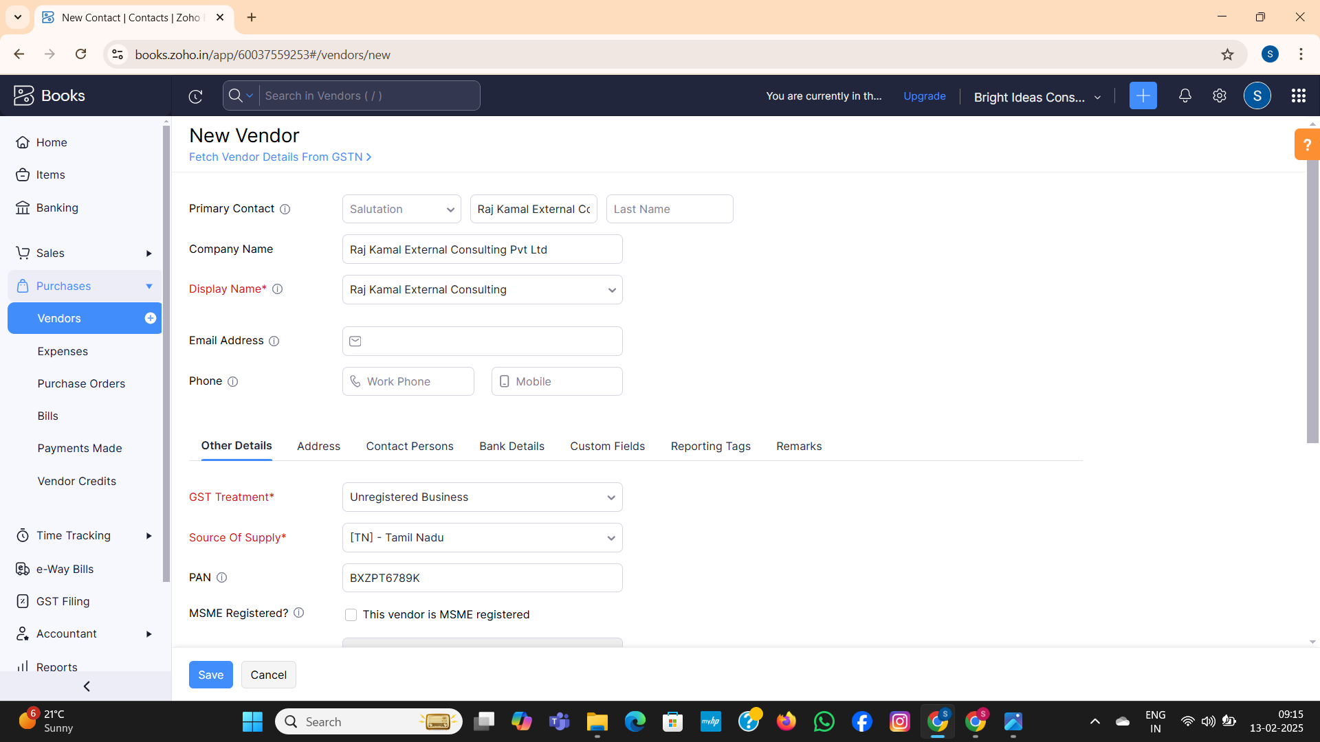

**Milestone-3**

**Activity-1**

1. **05/04/2023 Randstad Technologies**

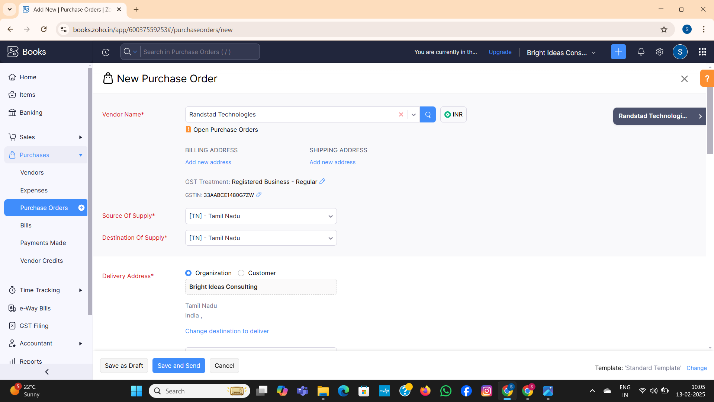

**Activity-2**

Purchase Order to Purchase Bills Conversion:

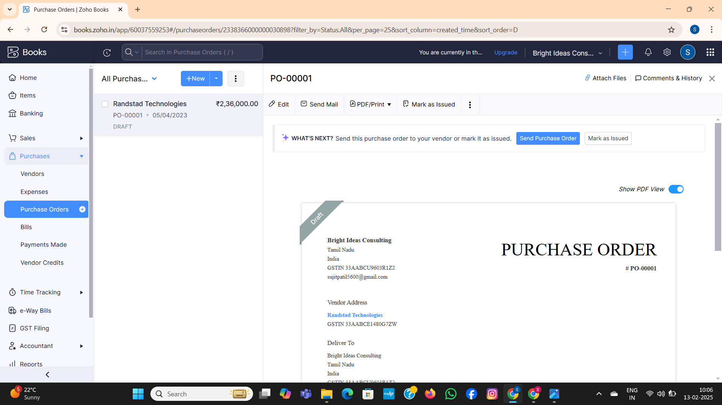

**Activity-3**

**Direct Vendor Purchases Bills Creation:**

1. Amazon Web Services

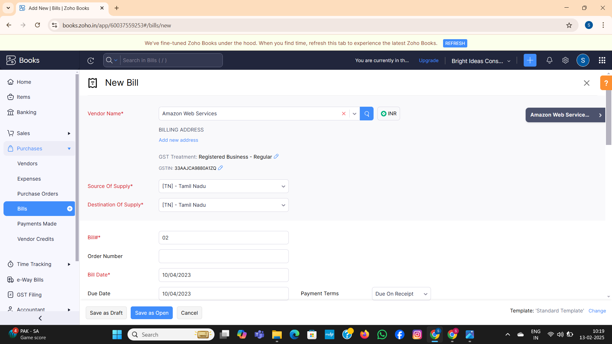

1. Raj Kamal External Consulting.

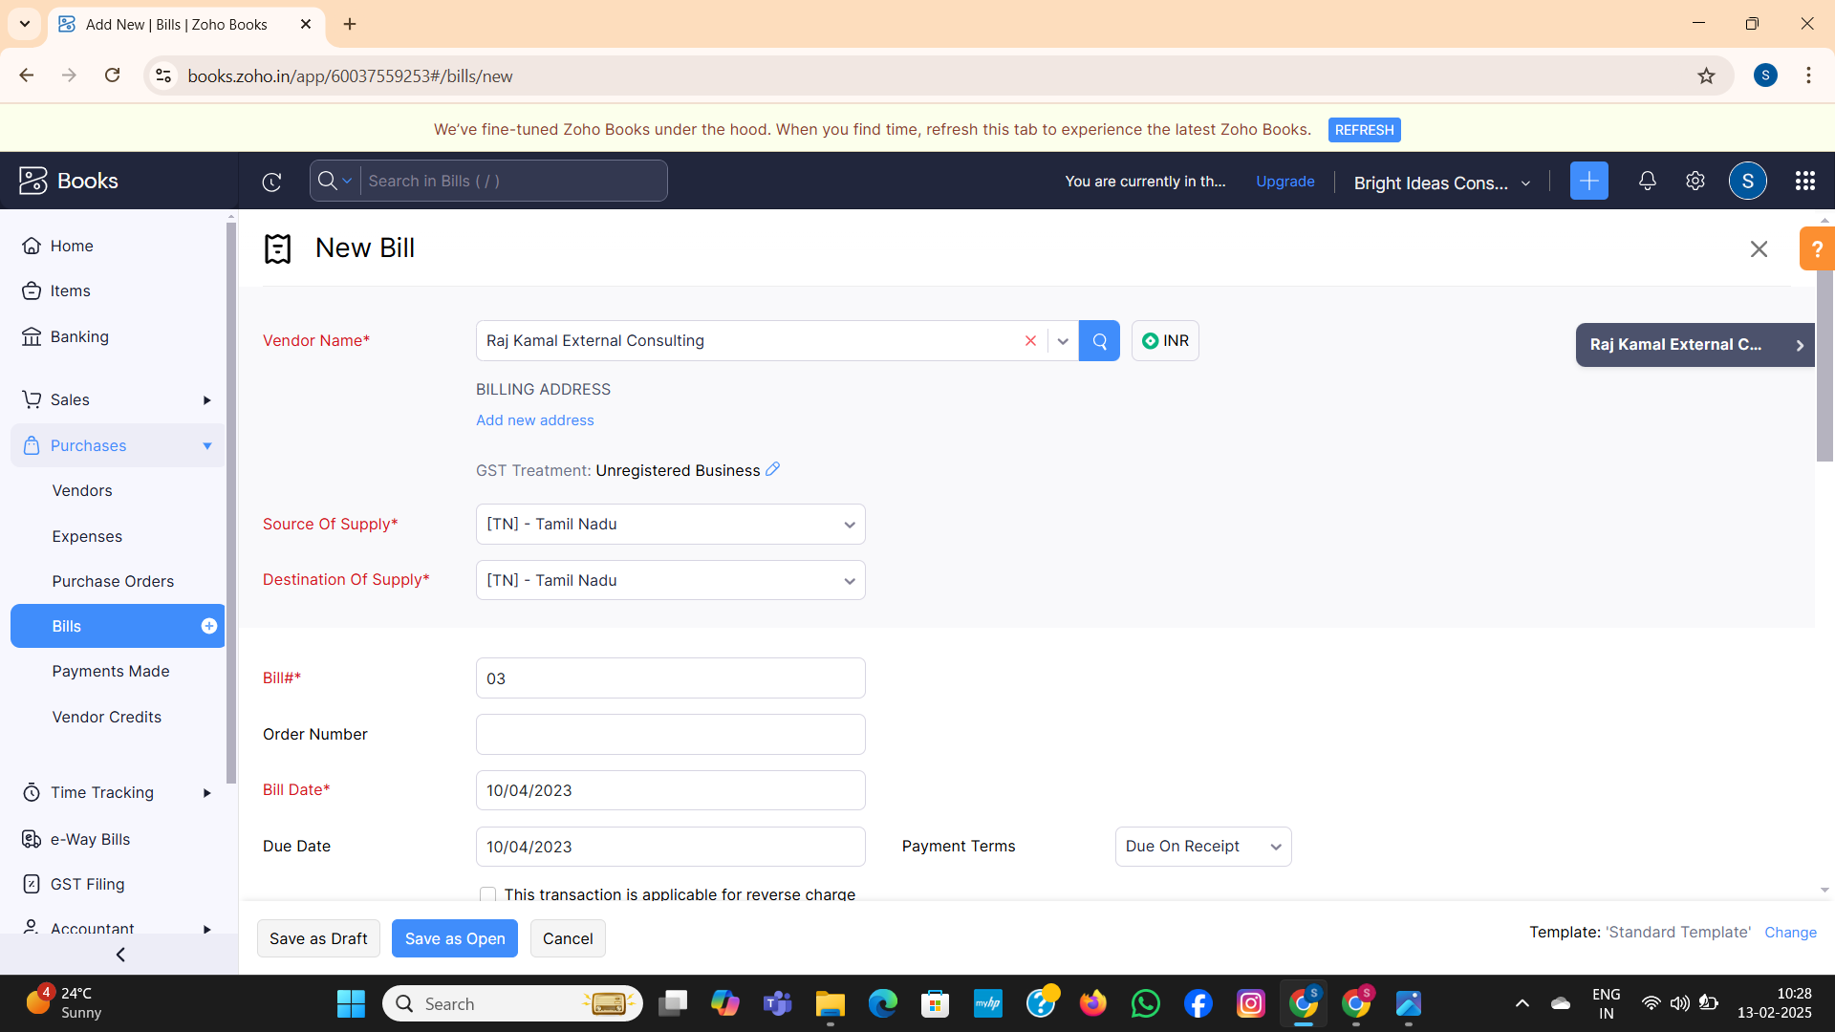

**Milestone-4**

**Customers Creation**

1. **Techwise Solutions Pvt Ltd (GST Registered):**

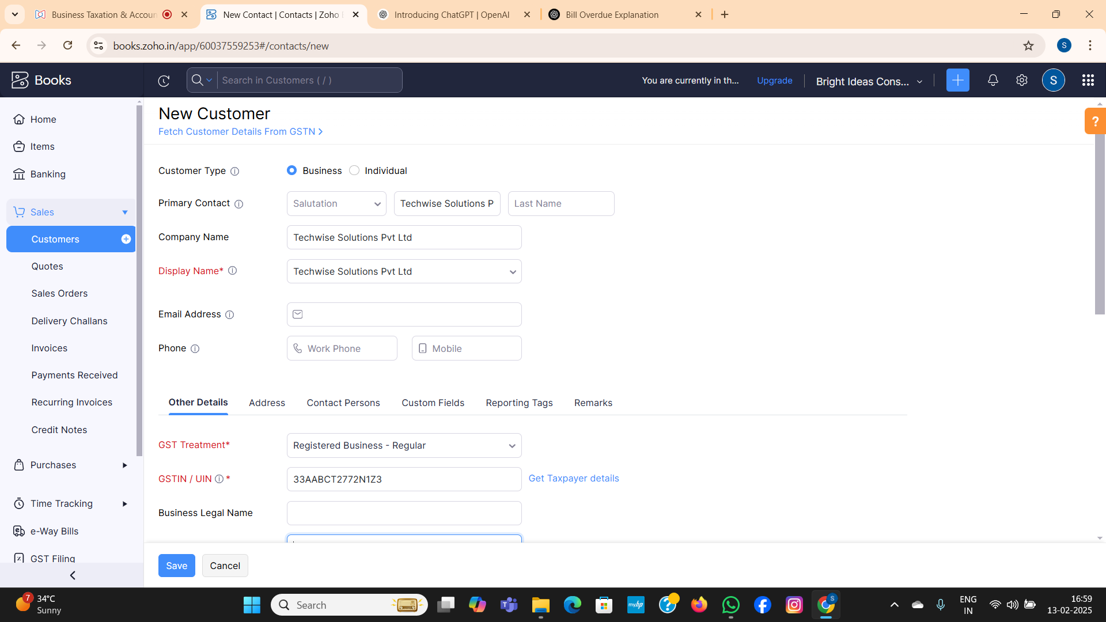

1. **DigitalEdge Technologies Pvt Ltd (GST Registered):**

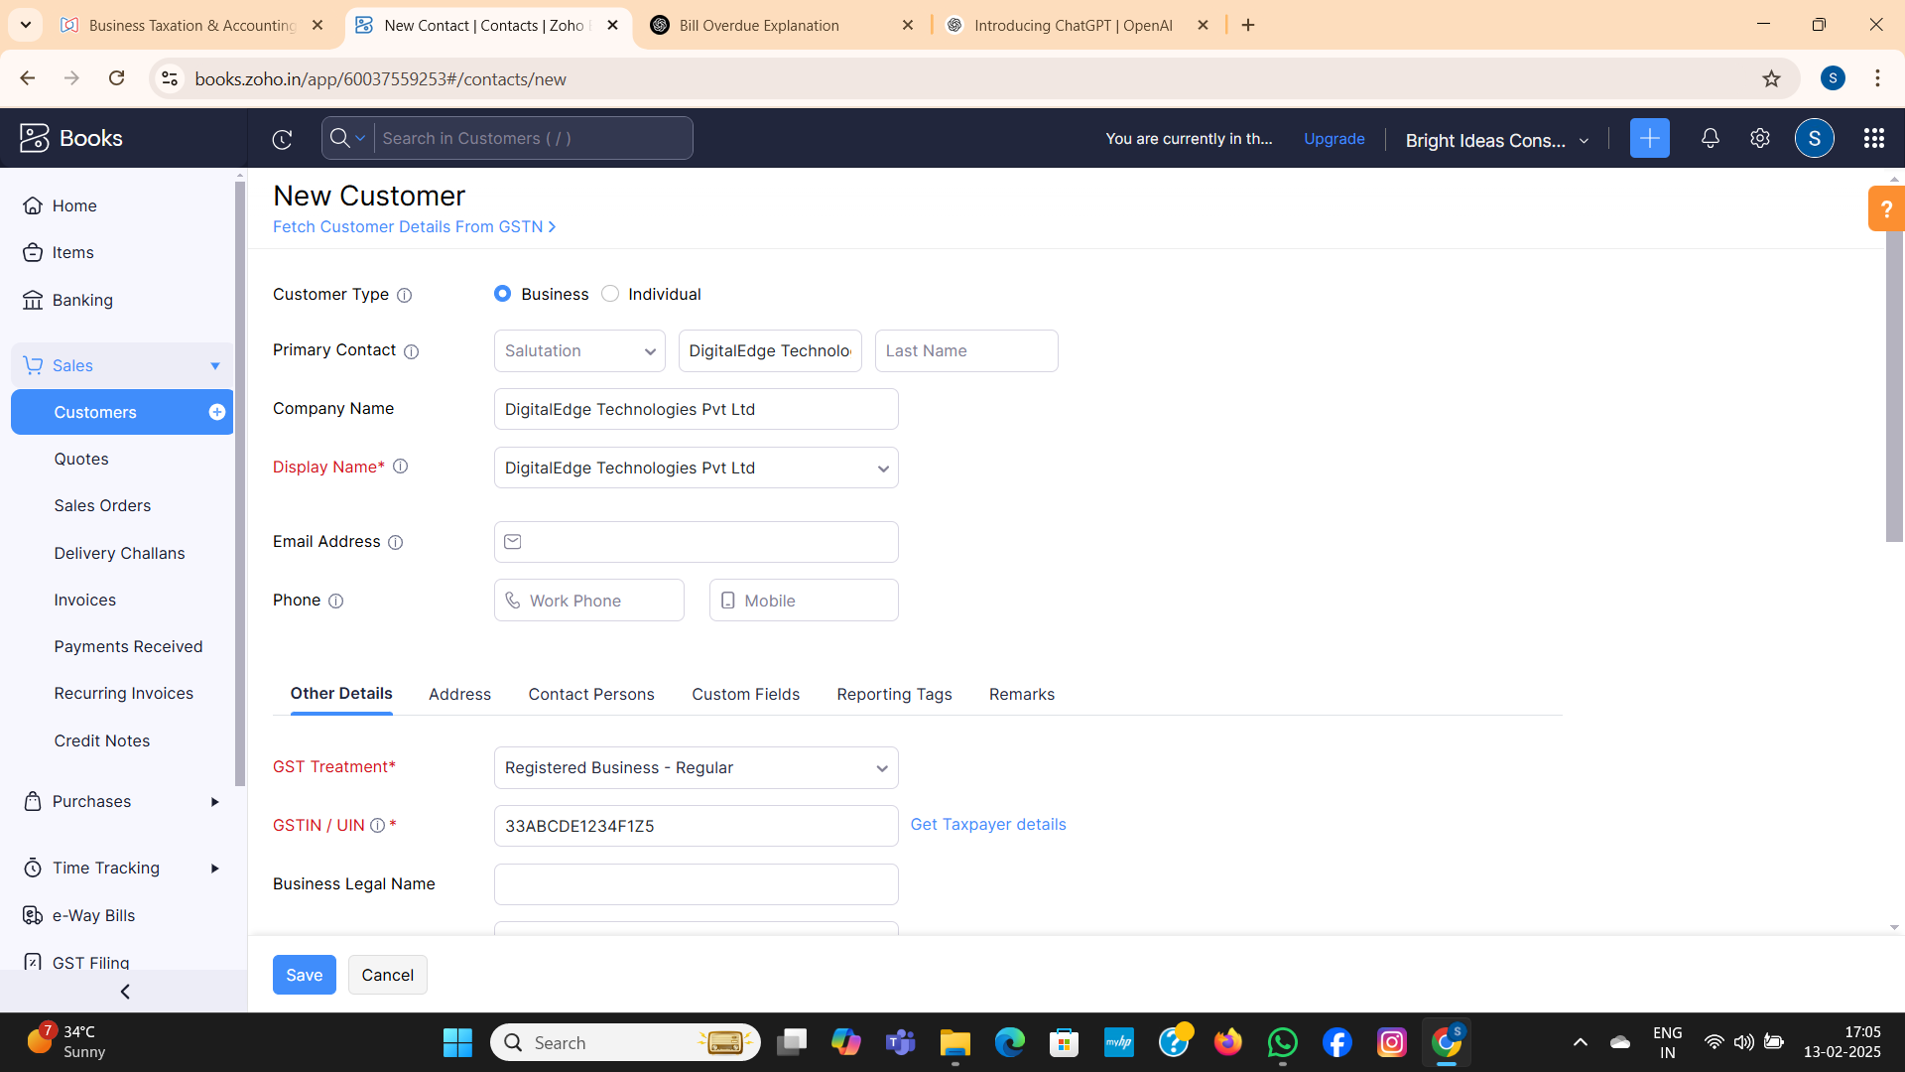

1. **SmartTech Innovations (Non- GST Registered)**

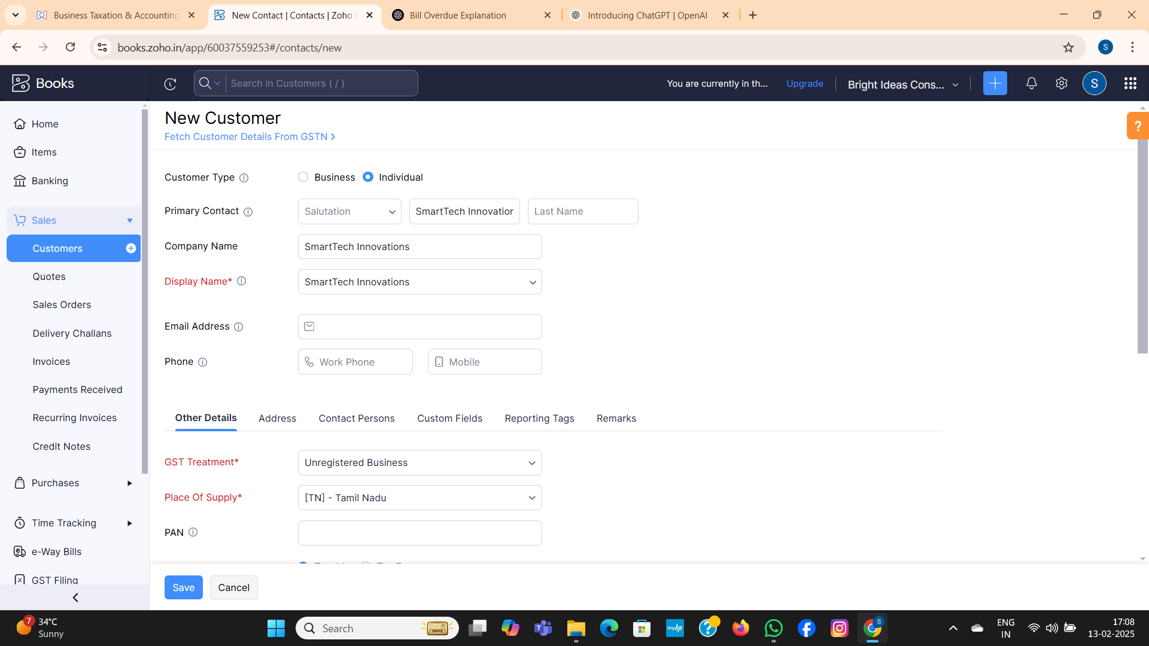

**Milestone-5**

**Sales Order Creation**

**Activity-1**

1. Techwise Solutions Pvt Ltd

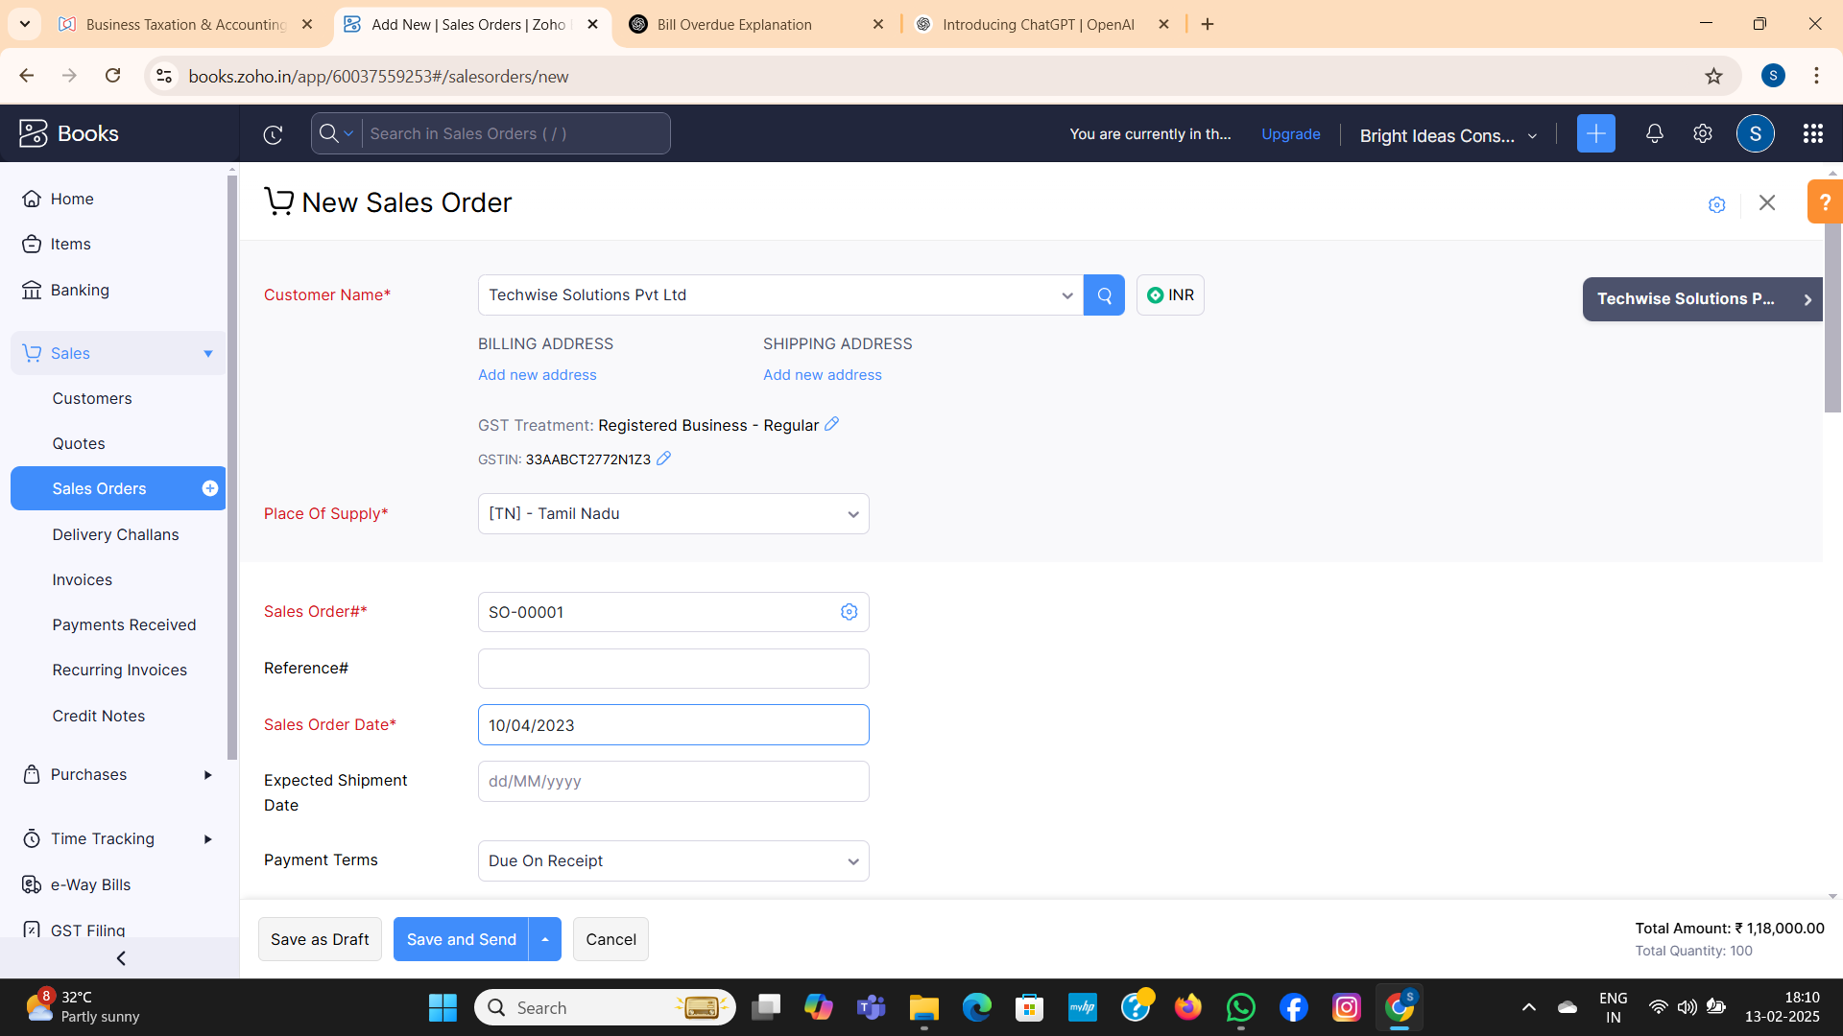

**Activity-2**

**Sales Order to Sale Invoice Conversion:-**

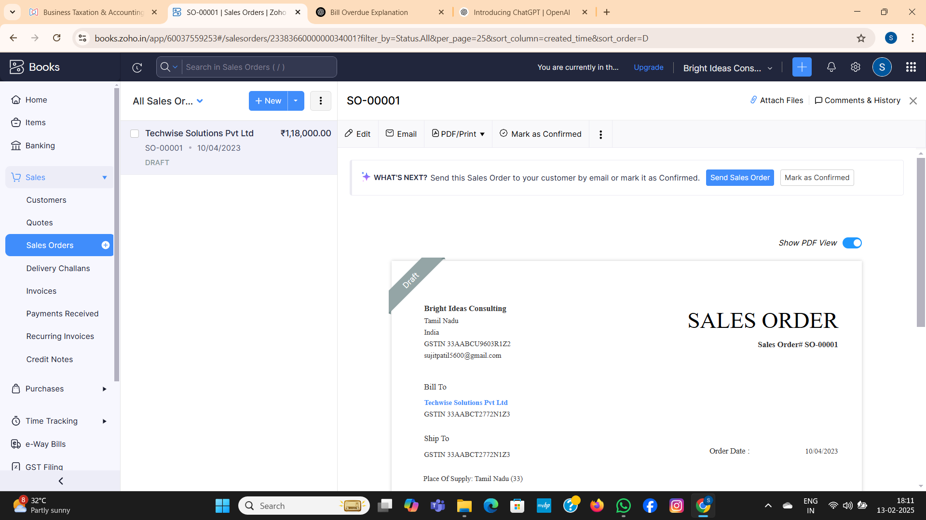

**Activity-3**

**Review of Techwise Solutions Pvt Ltd:**

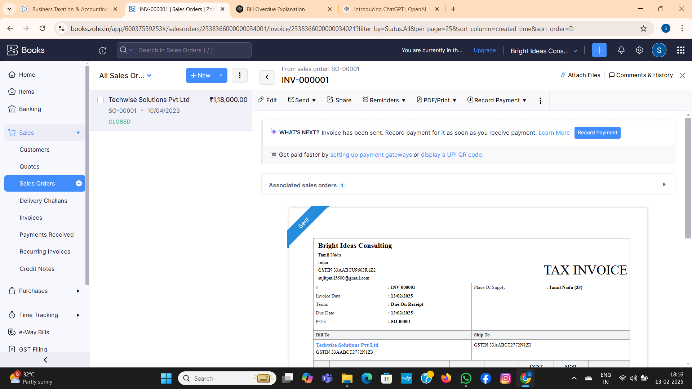

**Activity-4**

1. SmartTech Innovations Pvt Ltd 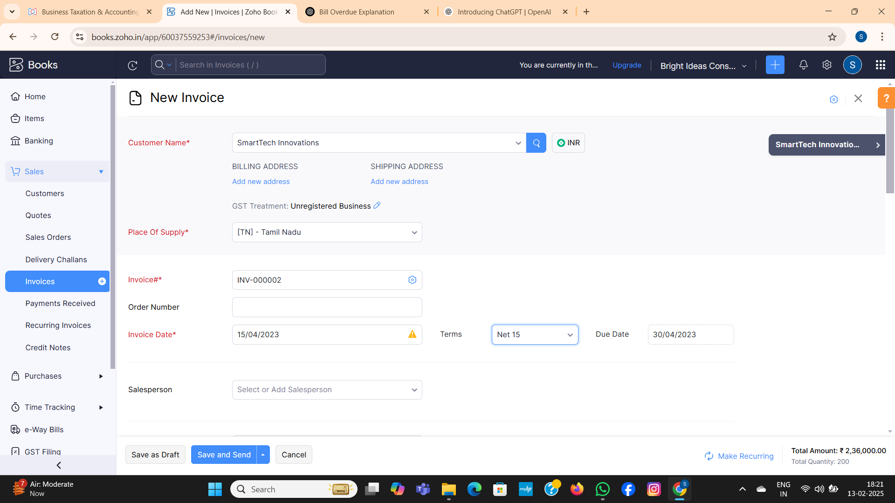
2. DigitalEdge Technologies Pvt Ltd

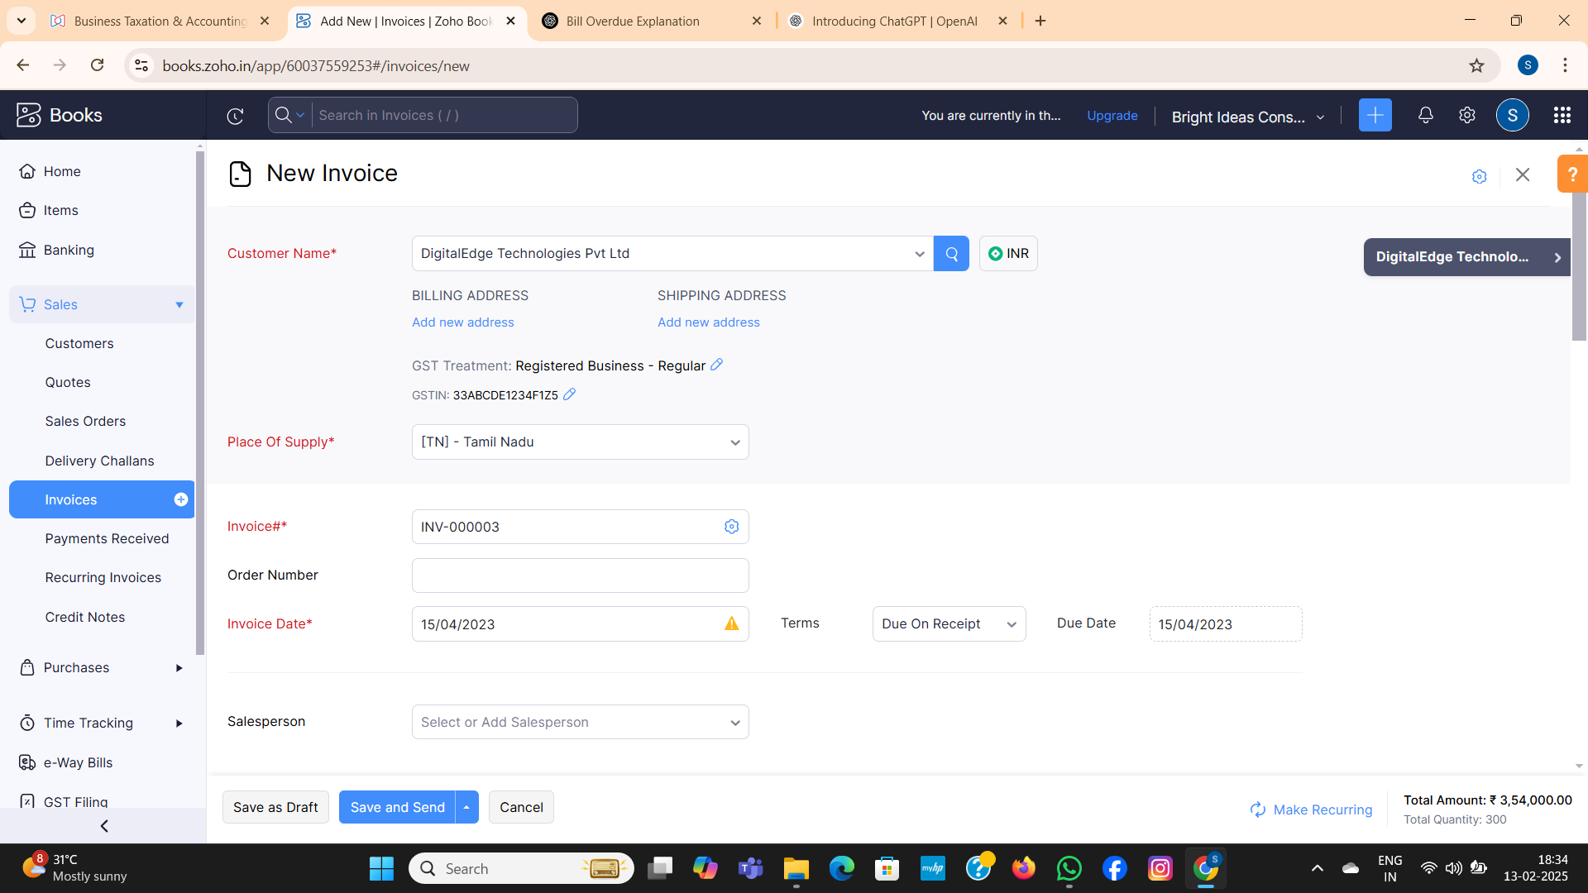

**Milestone-6**

**Adding Bank Account**

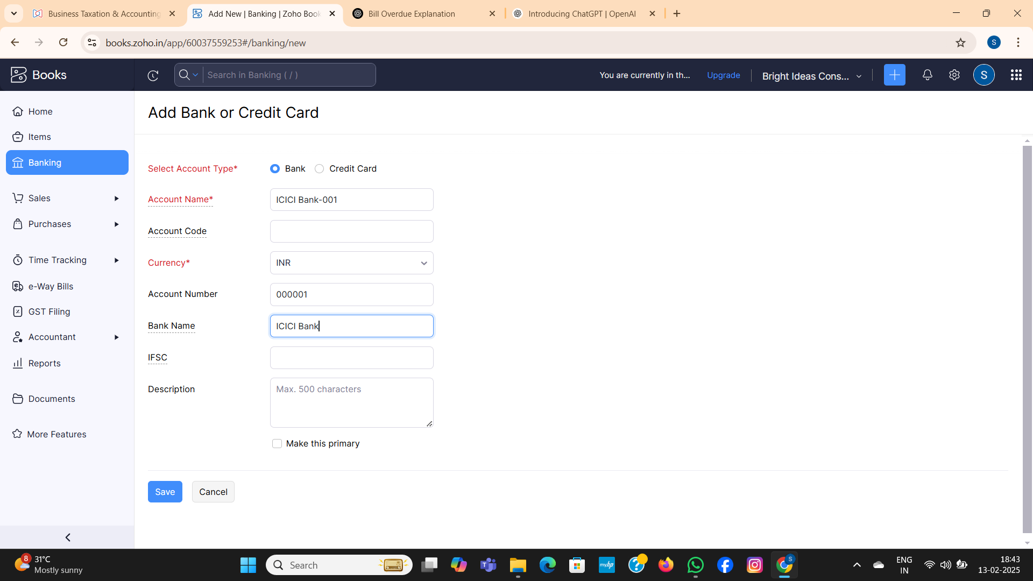

**Milestone-7**

**Journal Entries**

1. Employees Salaries of total Rs.1,00,000/- paid 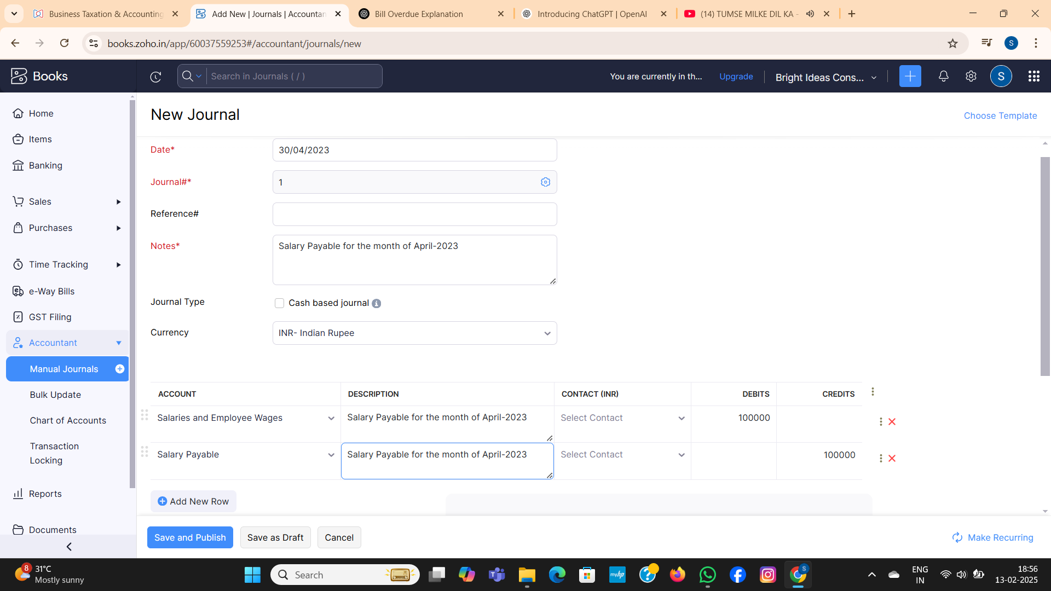

**Milestone 8**

1. Office Rent Rs. 1,00,000/- 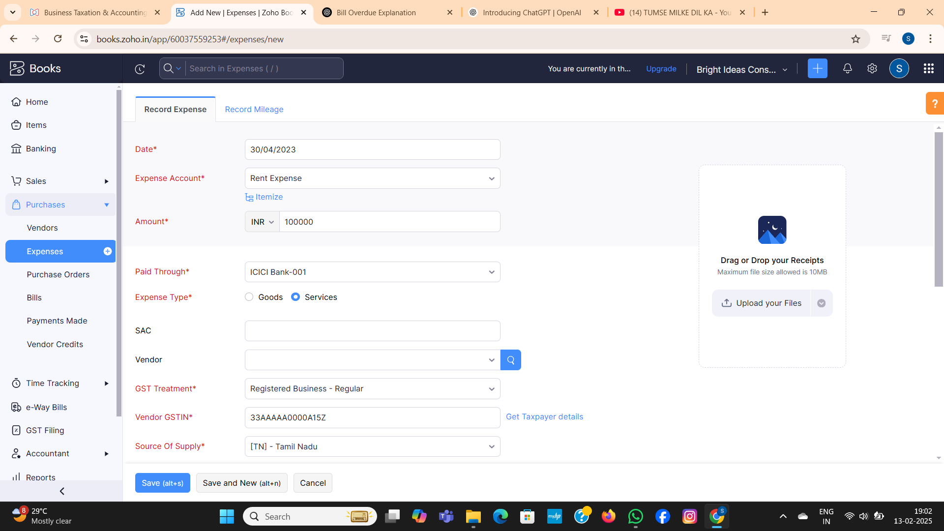
2. Other Miscellaneous Expenses Rs. 5,000/- paid in cash

